**TECHNOLOGY TNT STORE**

**DEPLOYMENT MANUAL**

Step 1: Download the all document of project from the given GitHub link

=> using: git clone <https://github.com/tannhac2310/TNT_Project_HCL>

Or

=> download by url: <https://github.com/tannhac2310/TNT_Project_HCL>

Step 2: Open MySQL WORKBENCH 8.0 CE - A database management tool 🡪 click on new SQL tab 🡪 execute all lines in techstore.sql file.

*Example: MySQL Workbench

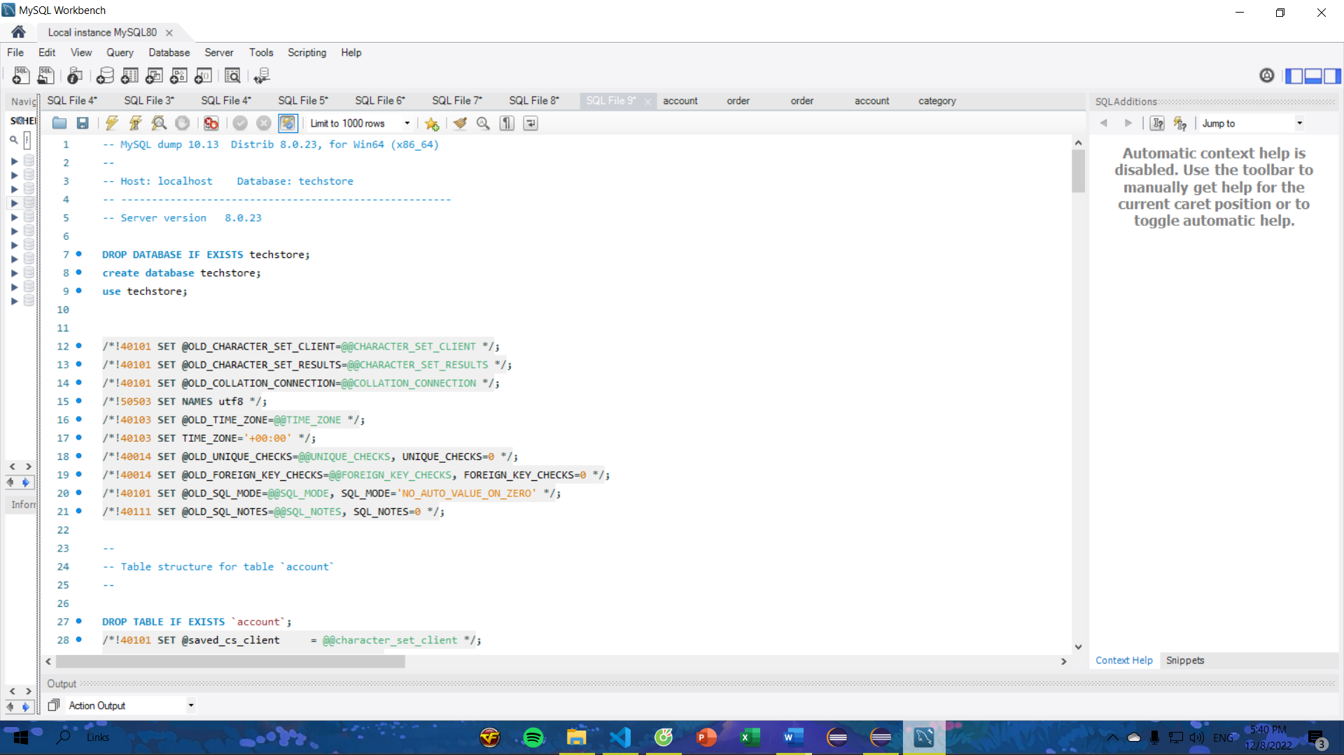

Step 3: Open Eclipse or STS and import the technology_store folder (with path ~ \Backend\ ).

Step 4: Go to your application properties and change the credentials according to your system.

Step 5: The port number we have given is 8094, if this port is busy, change the port number.

Step 6: Run the project as spring boot application as shown in the picture below.

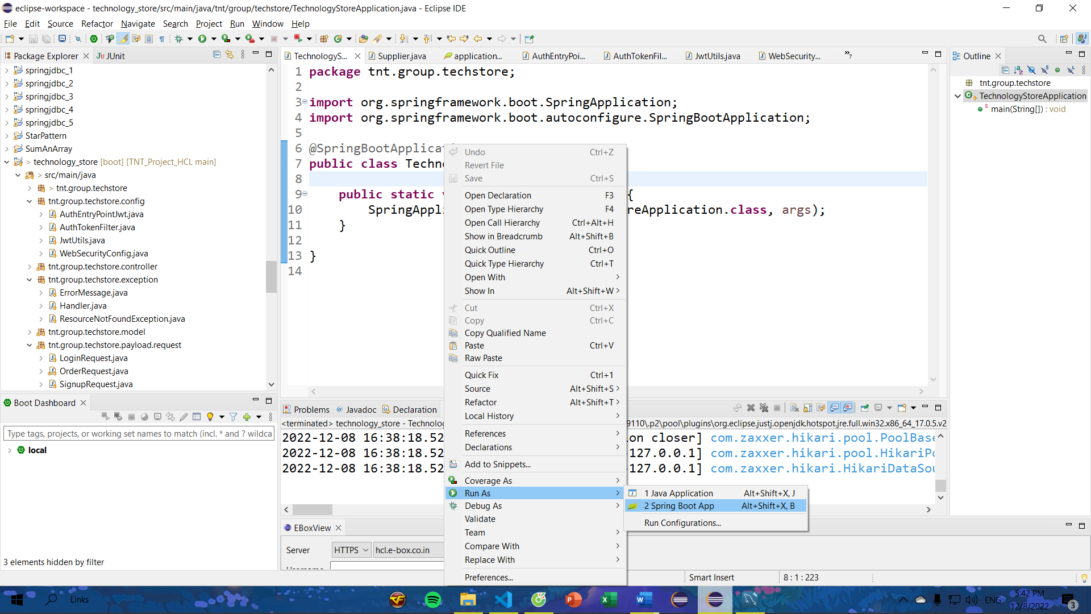

Step 7: If the program is successfully executed, the console will be as shown below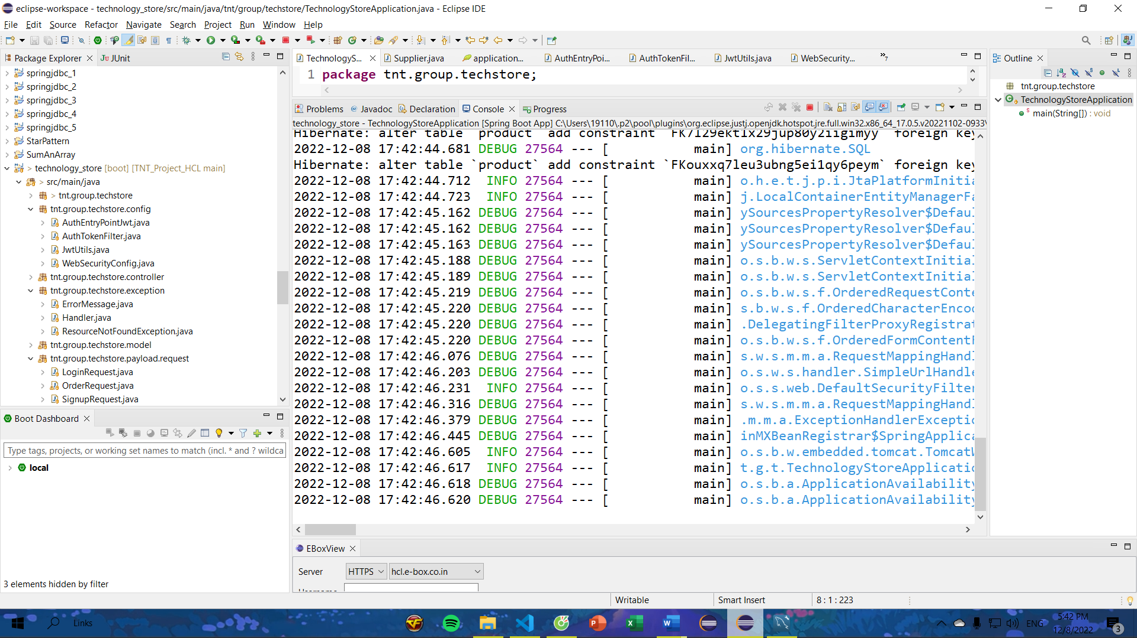

Step 8: Open VS Code and open the technology-store-client folder (with path ~\Frontend\ ).

Step 9: Open terminal and type “npm i”

*Note: if in step 5 you can change port other than 8094, please change port 8094 in API_URL string to that port in all service file

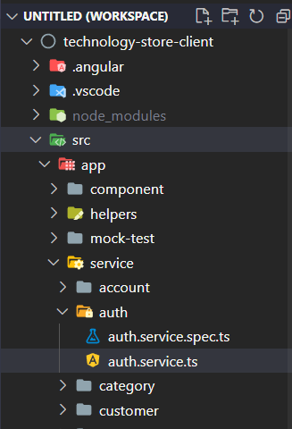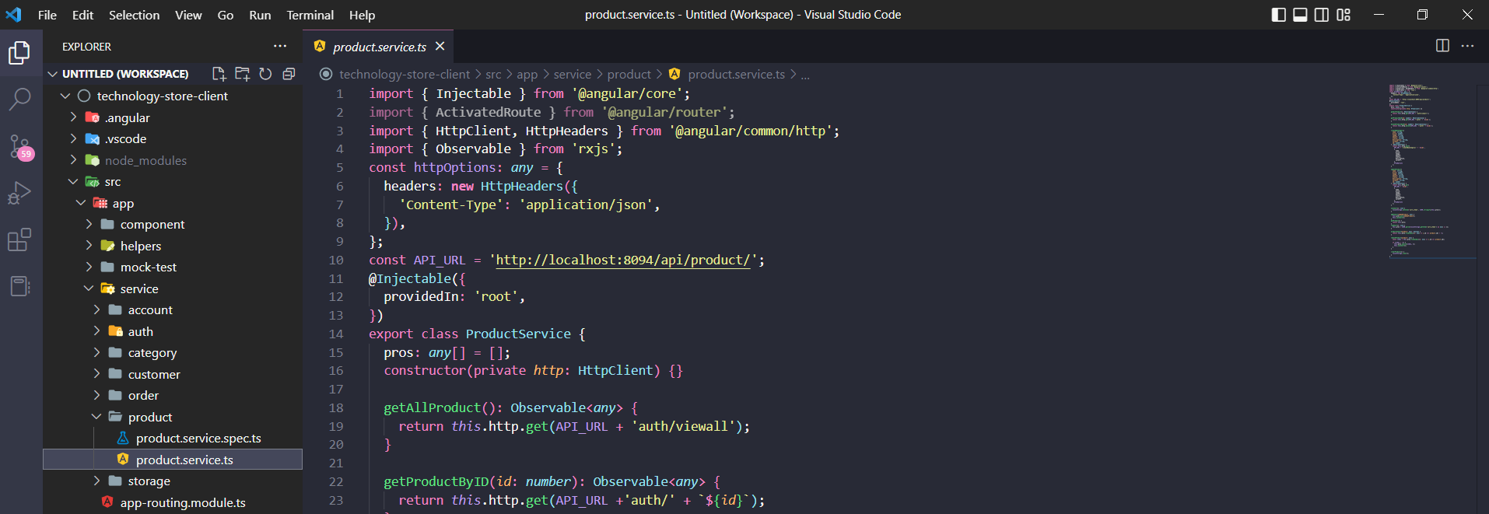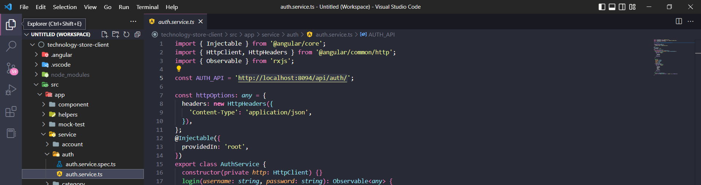

Step 10: Continue to type “npm start” in terminal

Step 11: If the program is successfully executed, the terminal will be as shown below

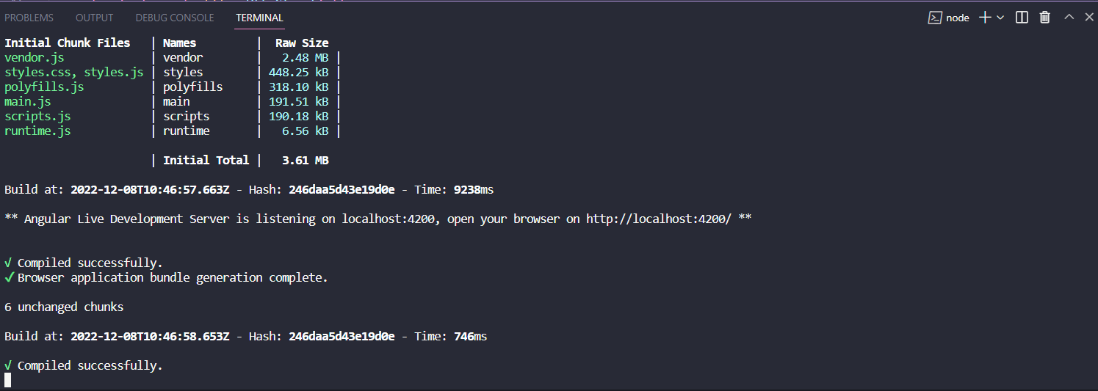

Step 12: Open up your web browser and type localhost:4200

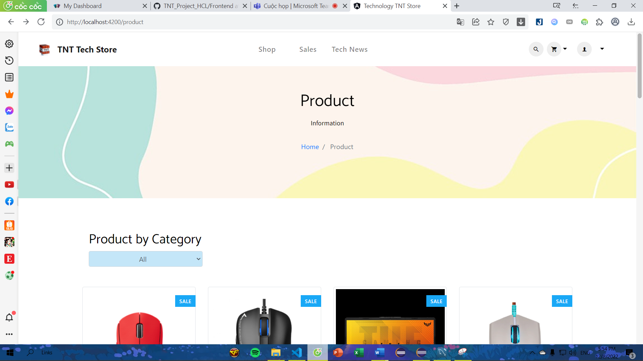

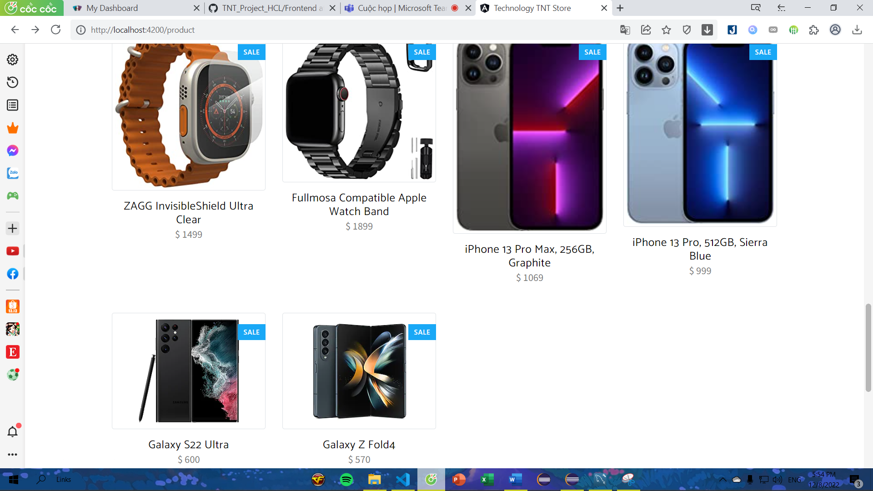

The main page

Step 13: To purchase products, you must log in to the system (all accounts in the database are provided in the table below)

- Admin

|  |  |  |
| --- | --- | --- |
| **#** | **Username** | **Password** |
| 1 | admin | 123456 |

- User

|  |  |  |
| --- | --- | --- |
| **#** | **Username** | **Password** |
| 1 | thanh123 | 123456 |
| 2 | JAS22084 | 123123123 |

OR also you can create new user

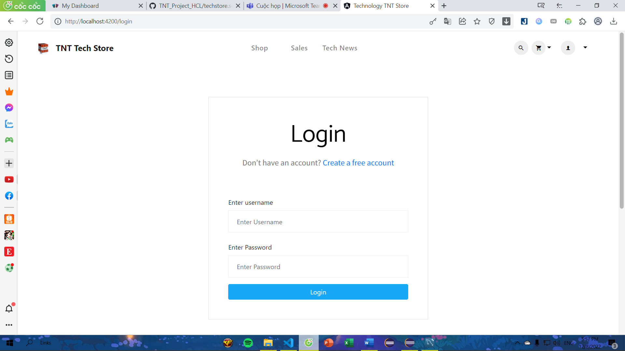

Login with username: JAS22084 and password: 123123123

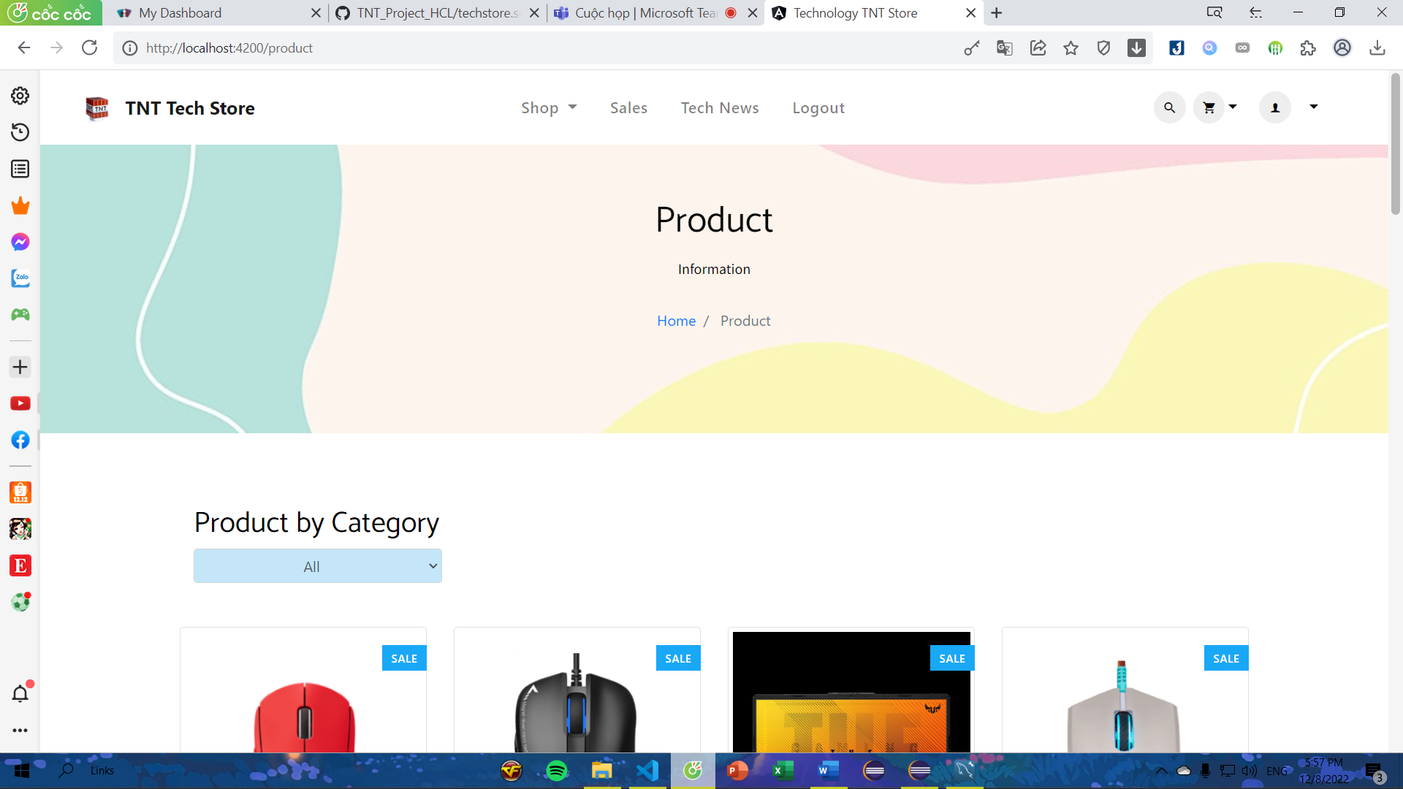

Login successfully in to the system

* Note: if you don't have an account, you can sign up by clicking "Sign Up" in the dropdown item in profile icon.

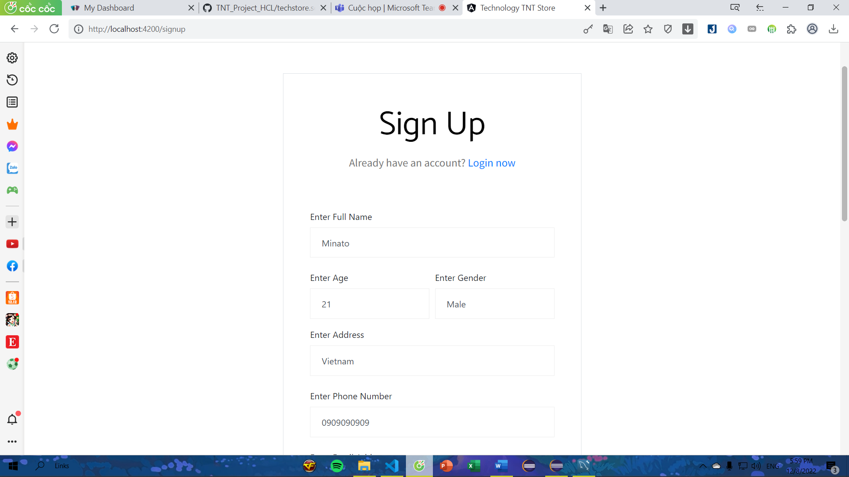

=> If you click Signup button with all valid value, the system will automatically redirect to login page

* Note: you can see my profile details and update if you want to change something

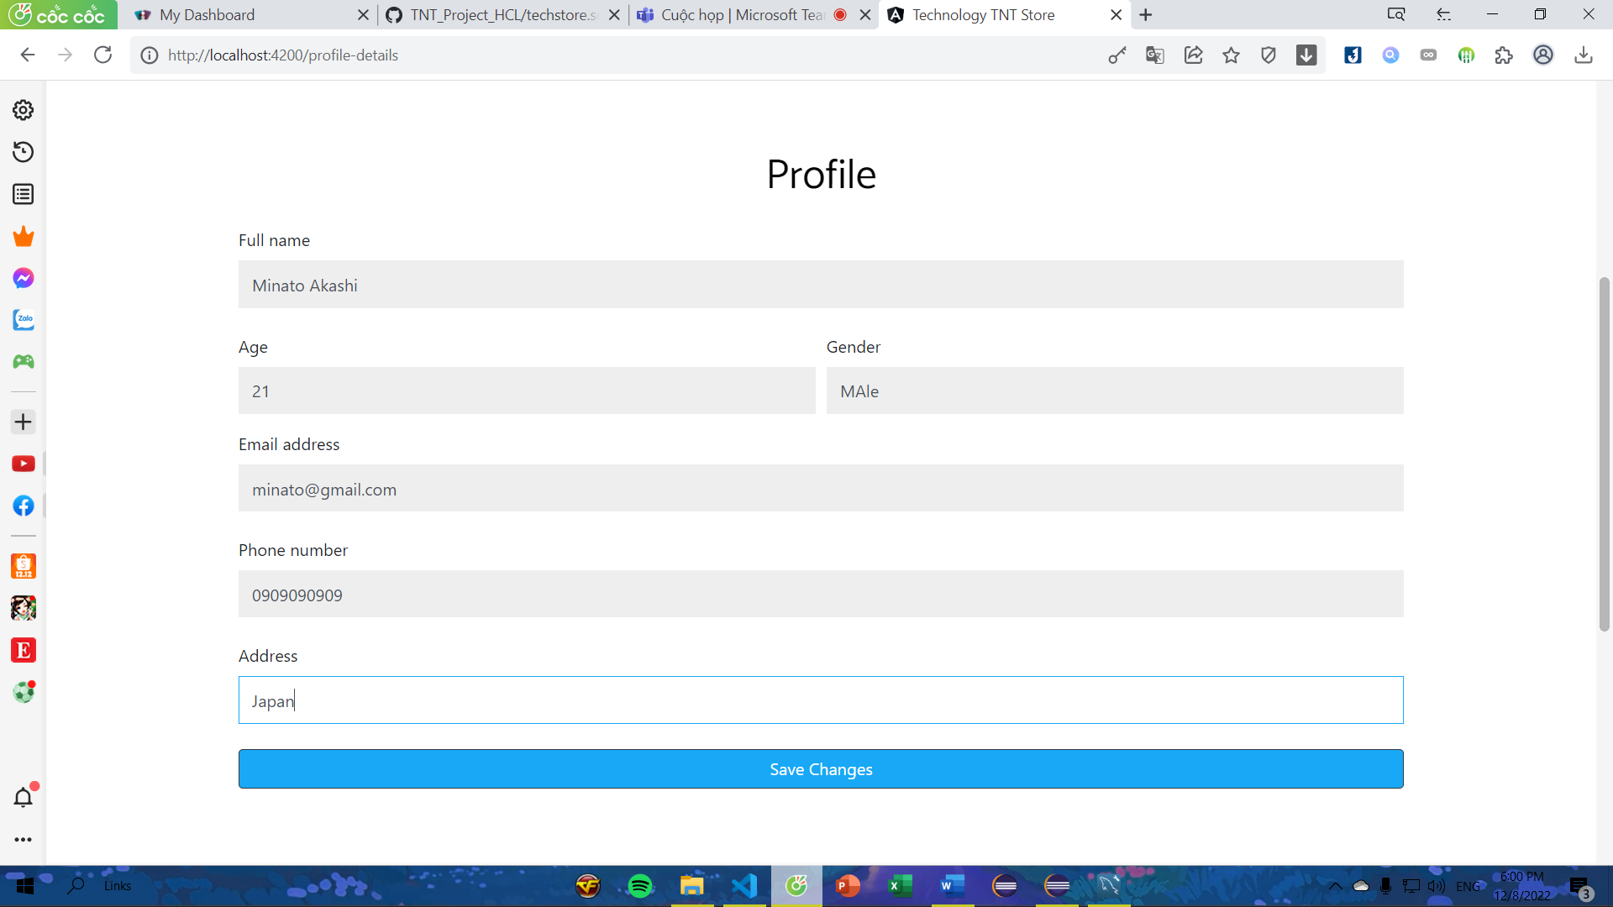

Step 14: Click "Home" in the dropdown item in Shop navigation bar.

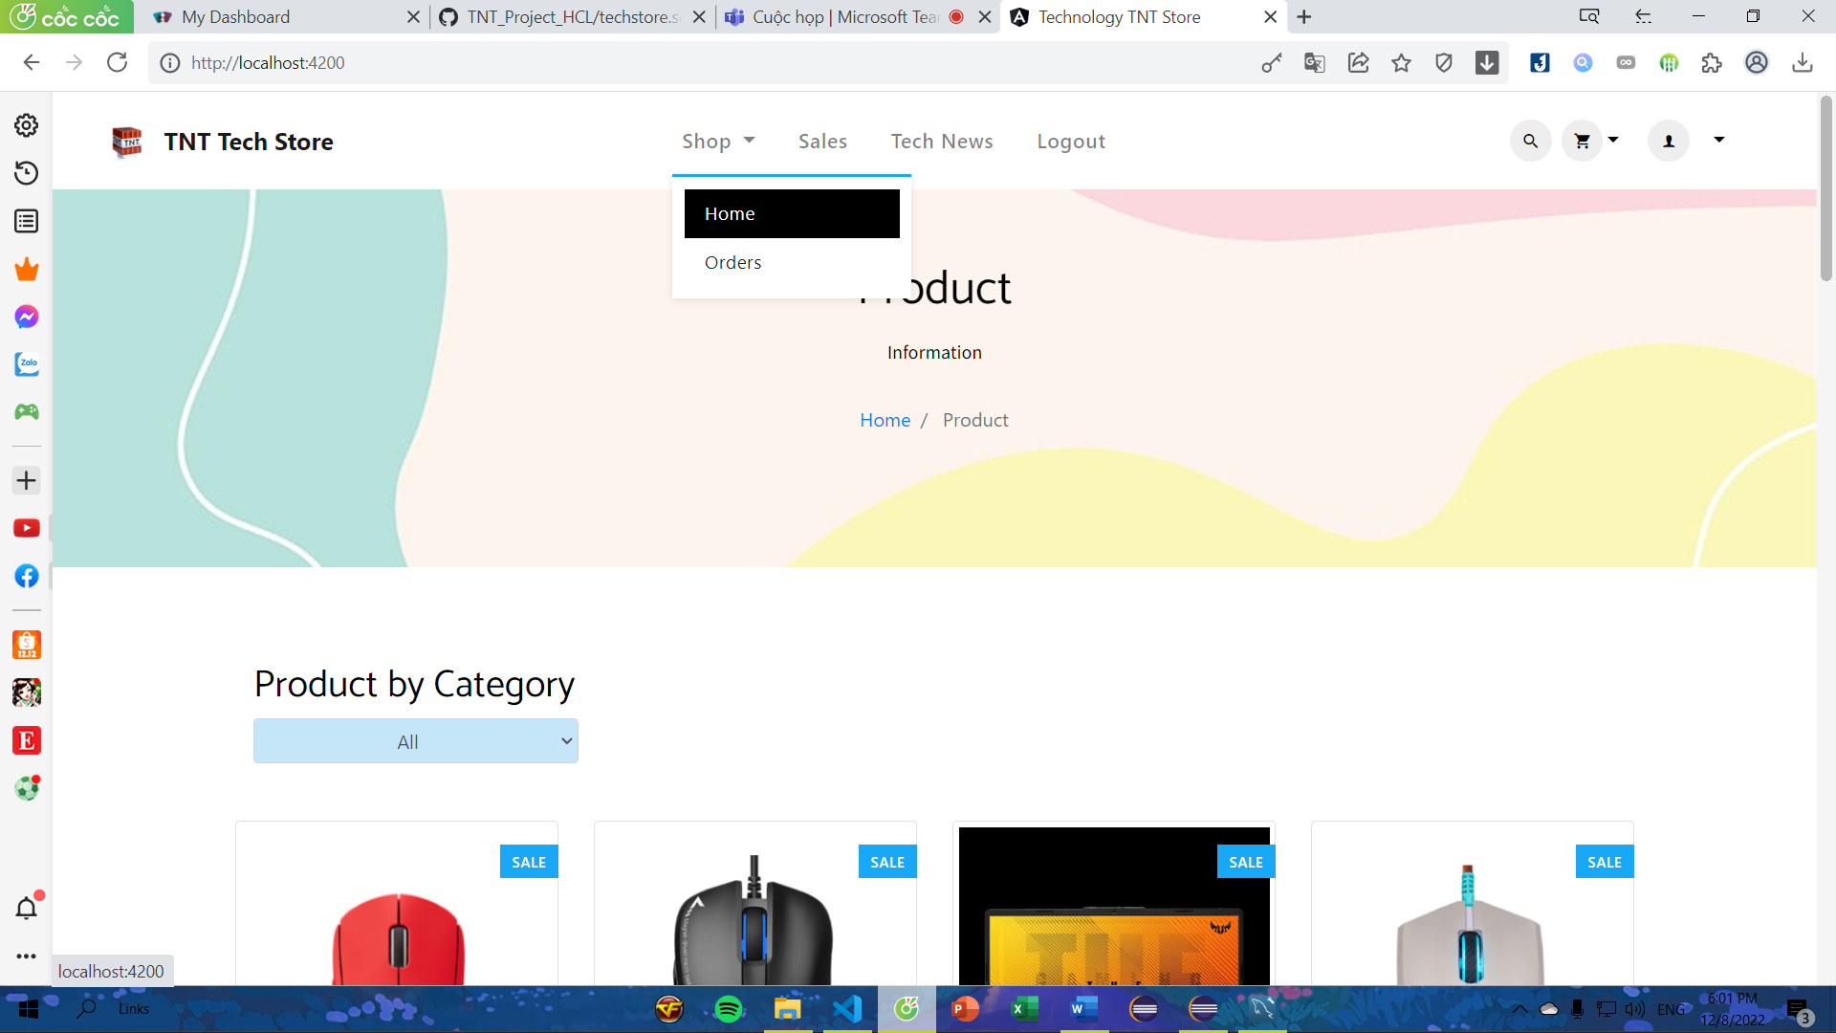

*View product by category

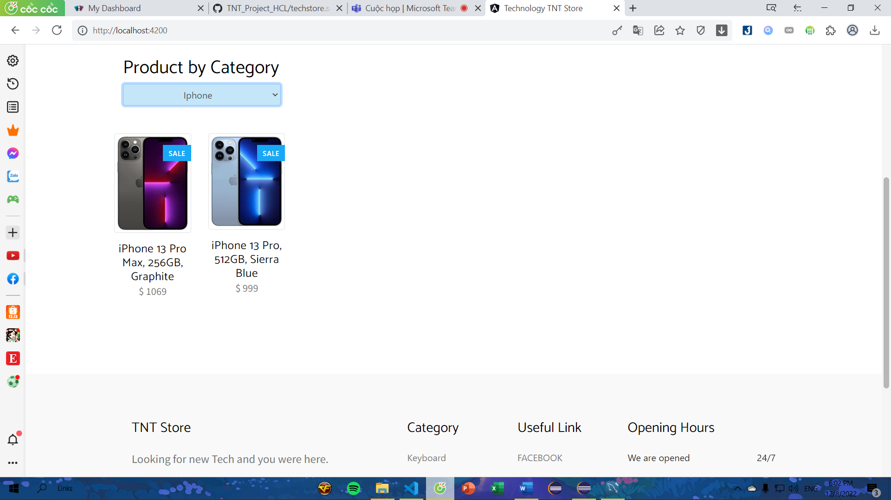

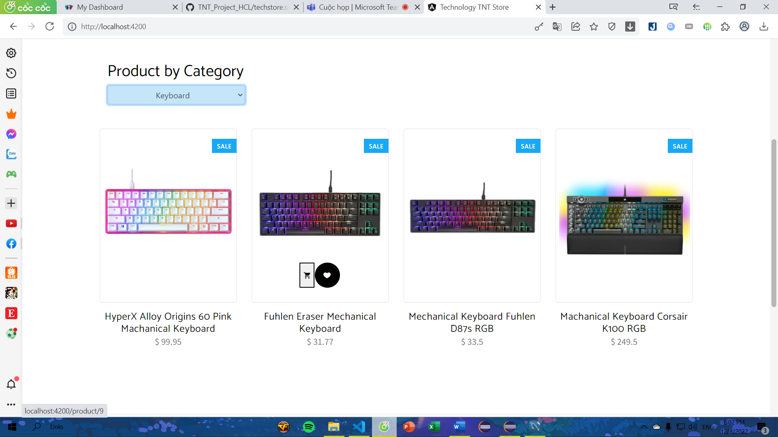

Step 15: Click anyroduct to see product detail

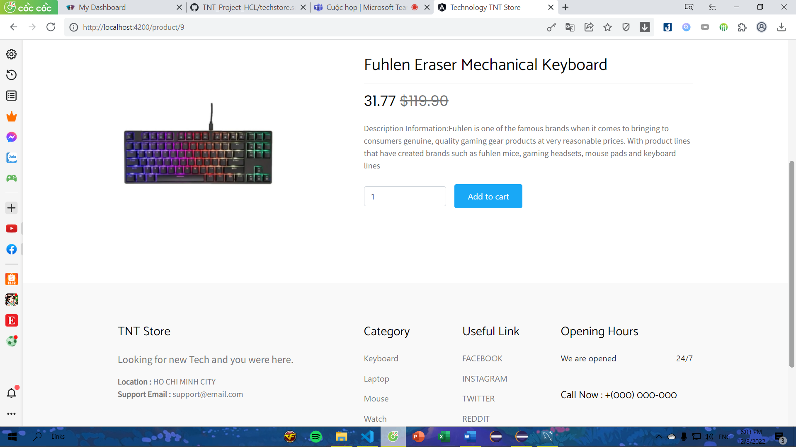

Step 16: To buy product click "Add to cart"

Step 17: After completing the purchase, click "View cart" to go to cart page

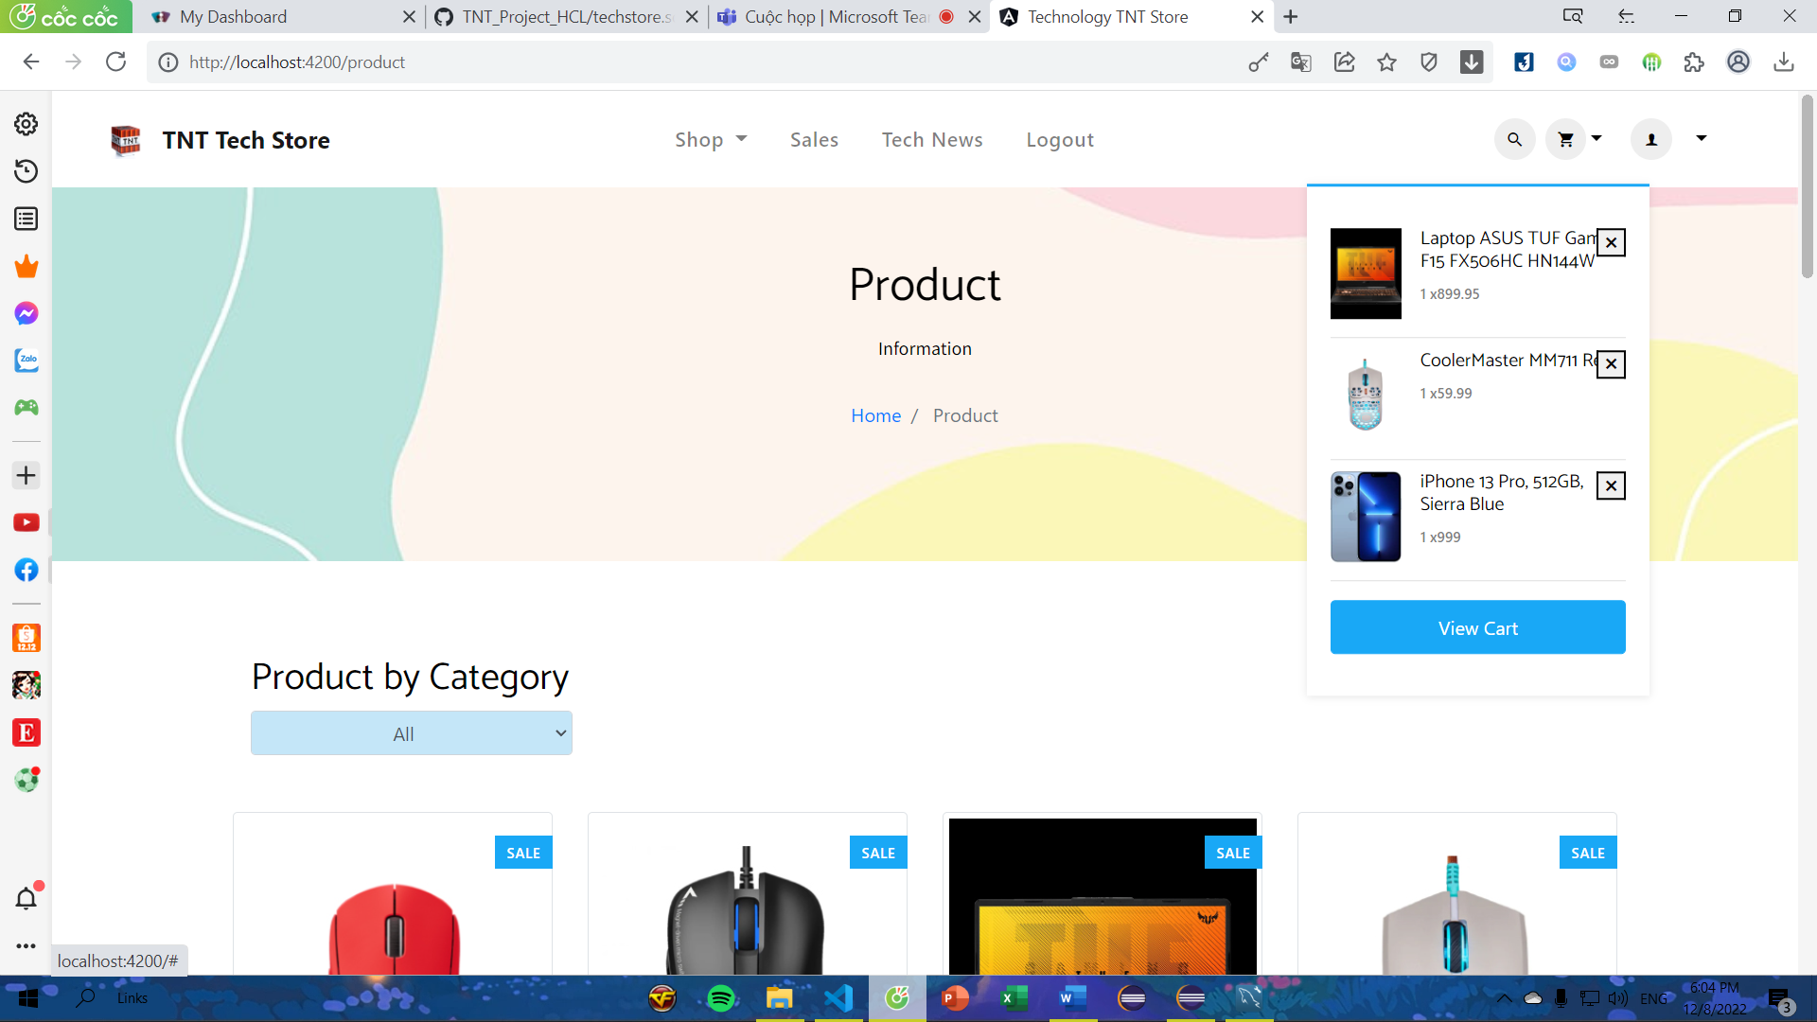

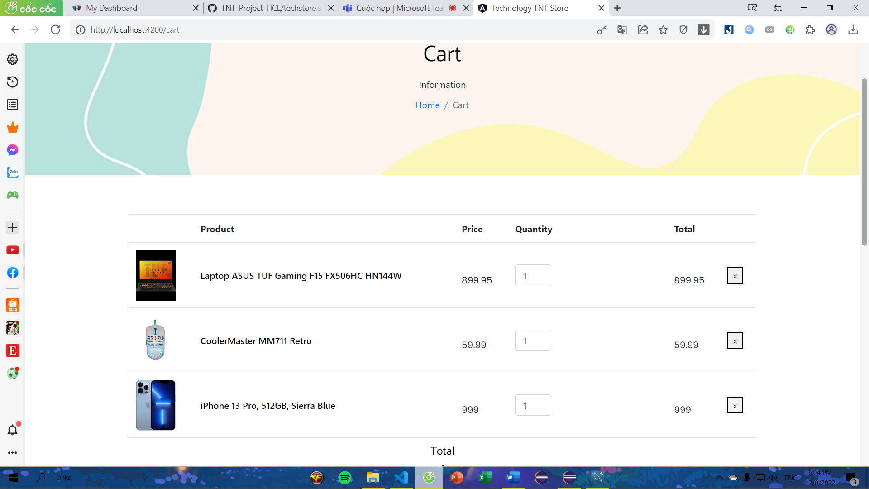

Step 18: Fill your phone number and address, and click "Order" to order

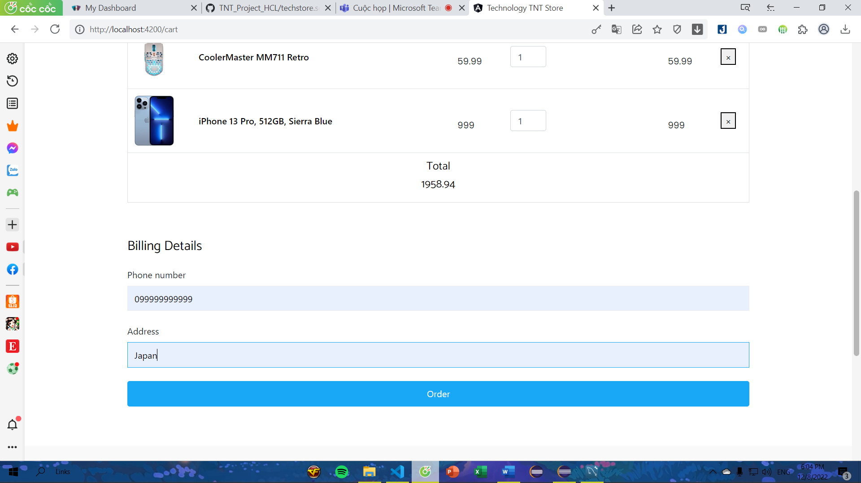

After successful order 🡪 order on dropdown item in shop navbar navigation

Step 19: Click "Orders" on the navigation bar to review all order information

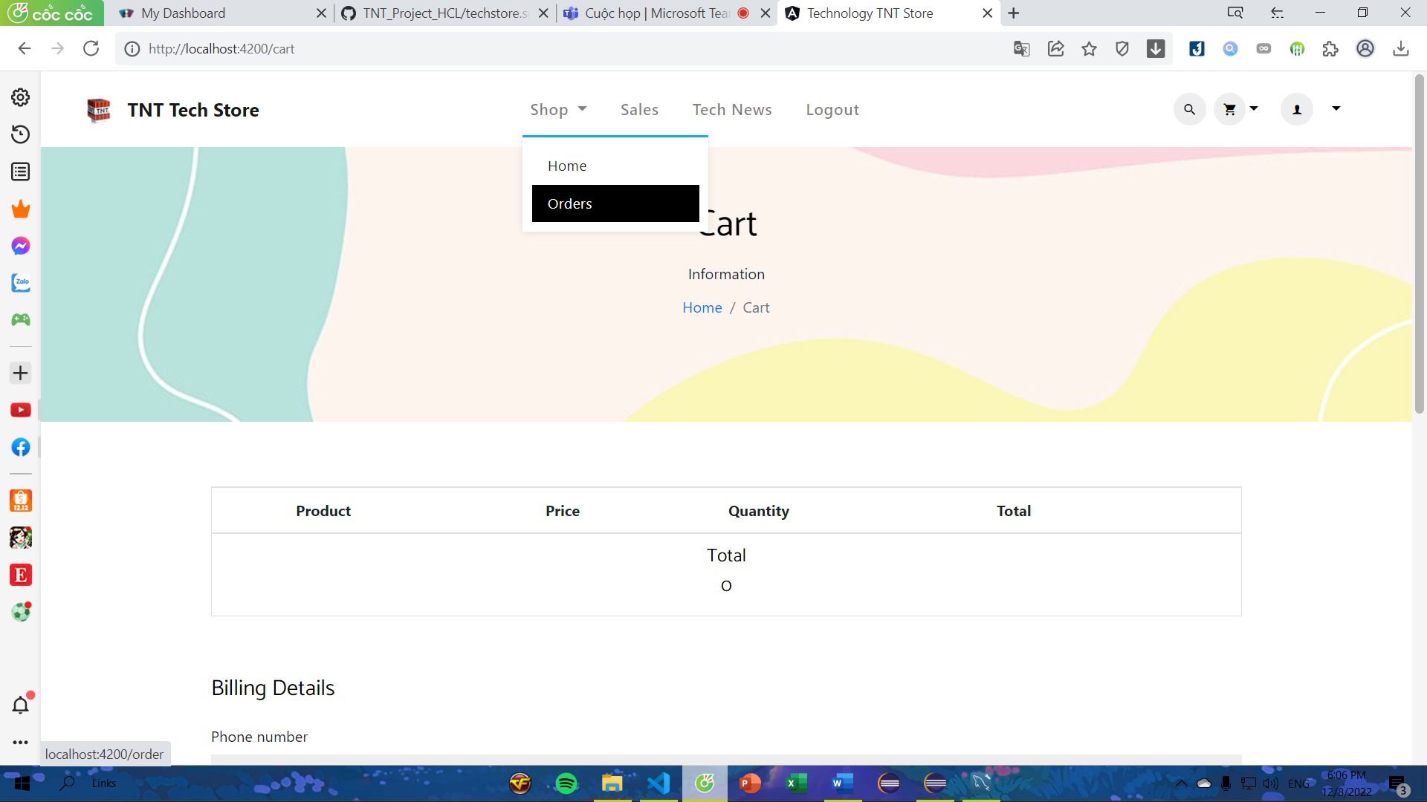

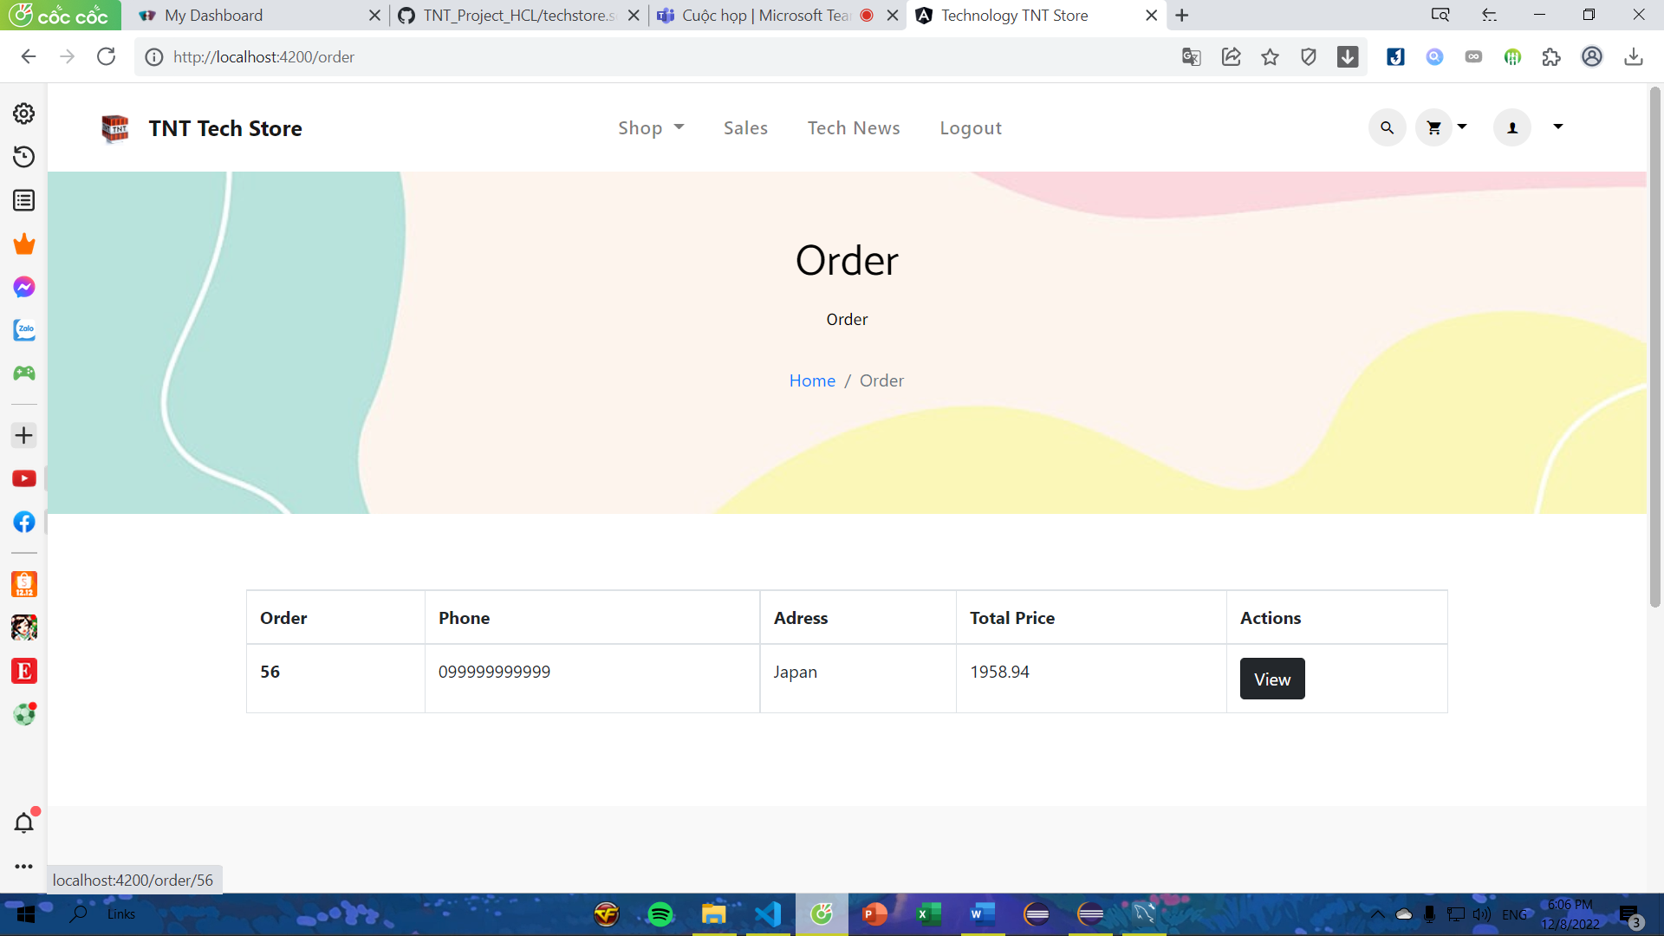

Step 20: Click "View" button to view order detail

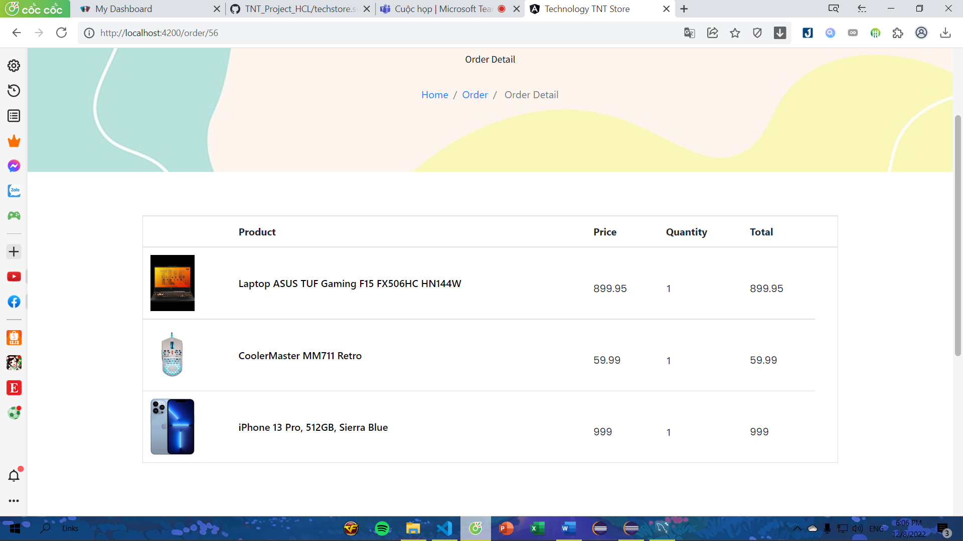

**With Admin role**

Click "Dashboard" on navigation bar to manage all product (CRUD)

- Read, Update and Delete product

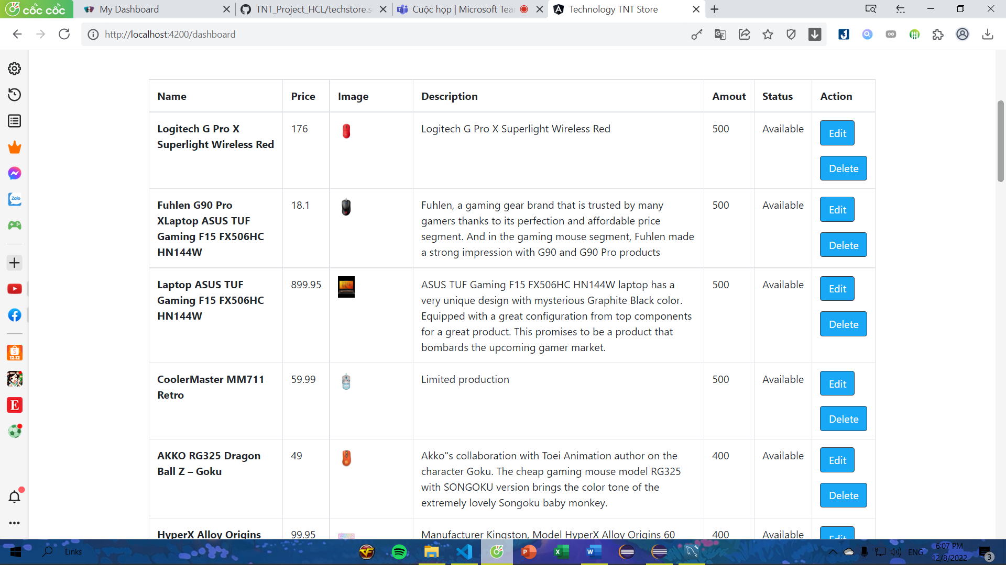

- Create new product

